Learning Self Monitoring
Unit 1-Global issues

Name: |  |  |  | Grade: | II M A B C  Esta guía es de autoevaluación. No tiene nota sumativa.  Solo evaluación formativa.  La fecha máxima de entrega es el día viernes 5 de junio. | Date
Puntaje Evaluación |  | 60
Puntaje obtenido:

1.-Choose the best option for each image( inicial-reconocer)(5 points)

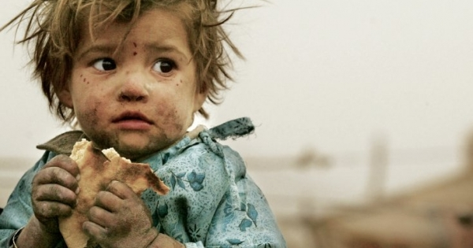
- Air pollution
- Commmodities
- Health care
- Hunger

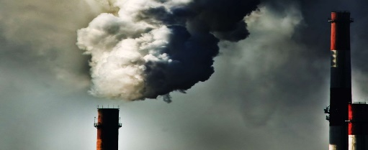
Esta foto de Autor desconocido está bajo licencia CC BY
- Poverty
- Commmodities
- Boundaries
- Air pollution
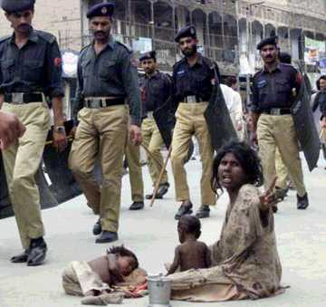
- Air pollution
- pollution
- Health care
- Poverty
- Poverty
- Health care
- Commmodities
- Air pollution
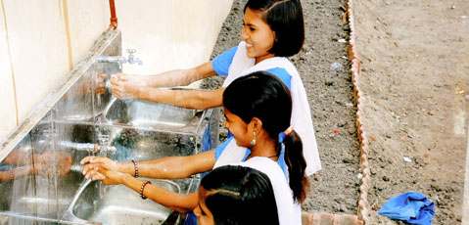
- Hunger
- Sanitation
- Poverty
- Air pollution

Item II
IDENTIFY THE BEST TITLE FOR EACH PARAGRAPH:10 points
1.- International organizations predict that rising prices for food commodities and increasing fuel prices will lead to an increase in the numbers of hungry people in developing countries over the next decades.

- Globalization
- Global food production
- Climate change
- Children’s rights

2.- Since the early twentieth century, global temperatures have been increasing gradually. There is growing international concern that climate change will impact on the economy, health, safety and security of many countries and their inhabitants.

- Sustainability of the planet
- Cultural diversity
- Climate change
- Children’s rights

3.- Indigenous people have inherited unique social, cultural, economic and political characteristics. The international community has recognized that indigenous people are vulnerable and that steps need to be taken to protect their unique cultures.

- Water shortage
- Ice shelf boundaries
- Global food production
- Cultural diversity

4.- Over the past years, scientists have been noticing a rapid disintegration of ice shelves on the Antarctic Peninsula and the northern coast of Canada. This process has had a huge impact on world climate, ocean currents and the wildlife in the area around ice shelves.

- Ice shelf boundaries
- Cultural diversity
- Climate change
- Children’s rights

5.- In 1989, world leaders decided that people under 18 years old often need special care and protection. A summary of the rights under The Convention on the Rights of the Child

- Globalization
- Global food production
- Climate change
- Children’s rights

Writing production 45 points
Write a short paragraph expressing your feelings towards cultural diversity;
Pay attention with your spelling and writing -Remember to use words like:
Nowadays, …(hoy en dia) It means that…(esto quiere decir) On the contrary,(por el contrario) … It doesn’t mean …(no significa)
I think that…(yo creo que) I don’t think…(yo no creo ) I disagree with…( estoy en desacuerdo) because…(porque) In my opinion, …(en mi opinión) I agree that (estoy de acuerdo que...)
- How multicultural is your school and your town?
- Are your customs different from / similar to your classmates’ customs? Why?
- What reasons can you think of for moving to a new country?
- What diffi culties do you think a migrant family would face in Chile?
- What are the advantages / disadvantages of living in a multicultural society?

CATEGORY | 3 | 2 | 1 | 0
Sentences & Paragraphs | All sentences and paragraphs are complete, well-constructed and of varied structure. | All sentences are complete and well-constructed (no fragments, no run-ons). Paragraphing is generally done well. | Most sentences are complete and well-constructed. Paragraphing needs some work. | Many sentence fragments, or run-on sentences, OR paragraphing needs lots of work.
Grammar & spelling (conventions) | Writer makes no errors in grammar or spelling. | Writer makes 1-2 errors in grammar and/or spelling. | Writer makes 3-4 errors in grammar and/or spelling | Writer makes more than 4 errors in grammar and/or spelling.
Length | The description is15 or more words | The description is 8-9 words | The description is 5-7 words. | The description is less than 5 words.

